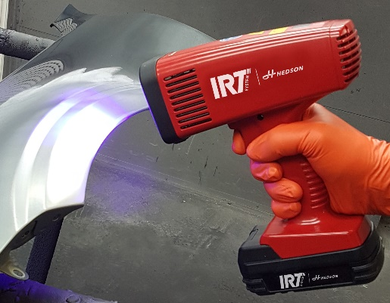
25 February 2020
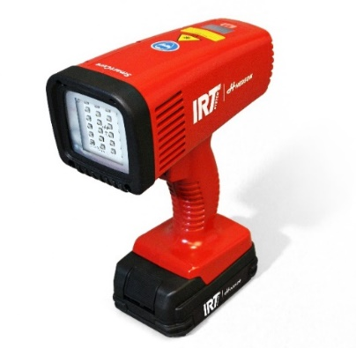

Image 1 (left): IRT UV SmartCure action, Image 2 (right): IRT UV SmartCure studio

IRT sets new UV-curing standard
IRT UV SmartCure combines a powerful UV-LED-module, advanced cooling technology and light weight batteries, resulting in considerably more effective UV-curing than present industry standard.
Full control
IRT UV SmartCure comes with two exchangeable, high quality long life 18 V lithium-ion batteries. Peak light and curing performance are maintained at a constant high level for up to 80 spot jobs throughout the complete battery cycle. No risk of power loss or overcharging. With an excellent light performance, IRT UV SmartCure cures UV-filler and primer considerably faster compared to industry standard.
Operational safety
Operational safety in every detail is IRT top priority. Advanced electronics minimizes the risk of machine damage by active ventilation and by monitoring the temperature of both electronics and LED-module. This also provides an efficient steady state voltage LED-output and current control regulation.
Developed with leading paint manufacturers
IRT UV SmartCure is made in Sweden and developed in cooperation with international refinish paint manufacturers to ensure 100% curing results. Using the IRT UV SmartCure, time savings in the prep area are significant. The design is comfortable and ergonomic. The UV-LED module sits safely behind a reinforced glass frame with scratch- and solvent resistant glass.
IRT UV SmartCure is supplied with twin battery pack, charger, protective eye wear and magnetic wall bracket.
“This is the start of a wide range of UV-LED models from IRT.”, says Linus Ekfeldt, IRT Product Company Director. “We have a head start using the know-how from our industrial projects, where we have supplied UV-based solutions for decades. We are very excited to proceed with the UV-LED technique.”
See IRT UV SmartCure and IRT-Booster live in Hedson expo stand at PaintExpo in Karlsruhe Germany, April 21st – 24th 2020.
IRT is specialized in infrared heating, drying and UV curing, holding a market leading position for over 50 years. IRT is part of the Hedson group, a leading supplier of premium curing, lifting, dust extraction and cleaning systems for auto workshops and industry worldwide.
Press contact: Linus Ekfeldt, IRT Product Company Director, +46 70 855 25 23, linus.ekfeldt@hedson.com.

